Retos iniciales Android Studio

1) Cambia el color de un tema
Para poder cambiar el color de un tema en Android Studio, debemos ir a la parte superior de la ventana y pulsar en “Ajustes” → “Temas”

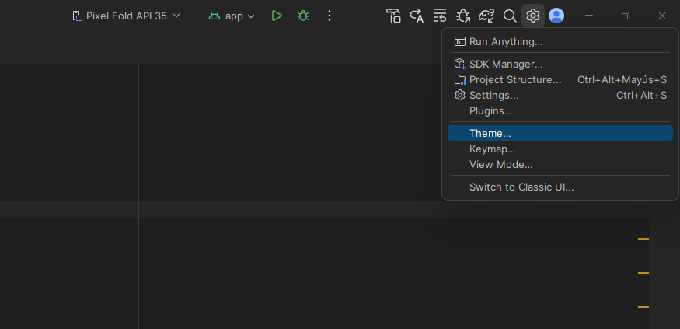

Una vez pulsemos ahí, se nos abrirá una pequeña ventana para poder cambiarlo utilizando los que vienen instalados por defecto, o si lo preferimos, buscar más en marketplace.

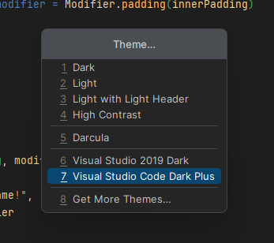

2) Captura de los plugins

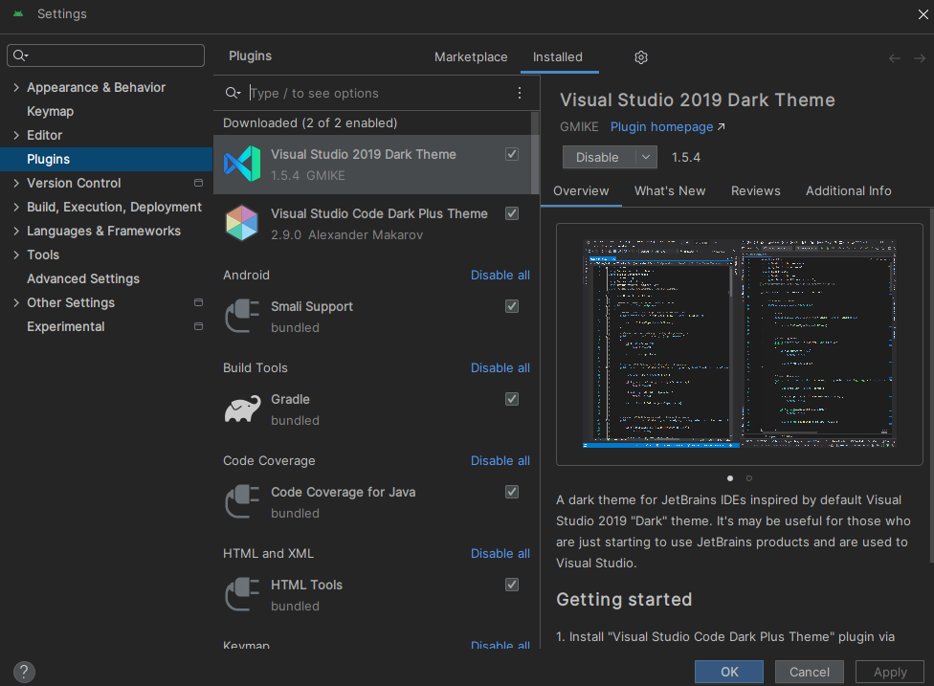

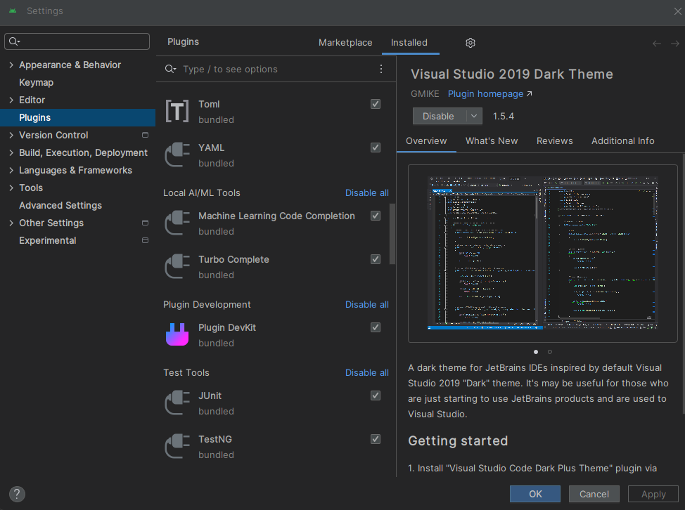

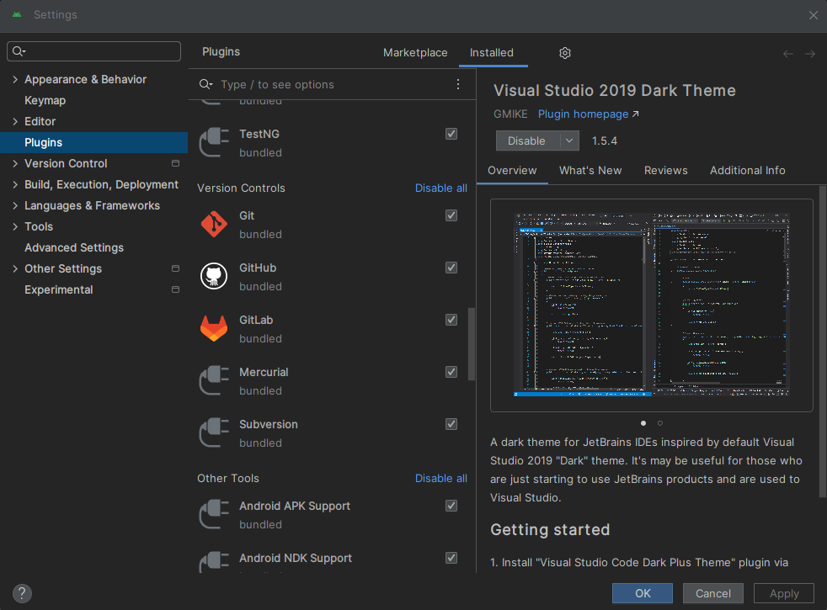

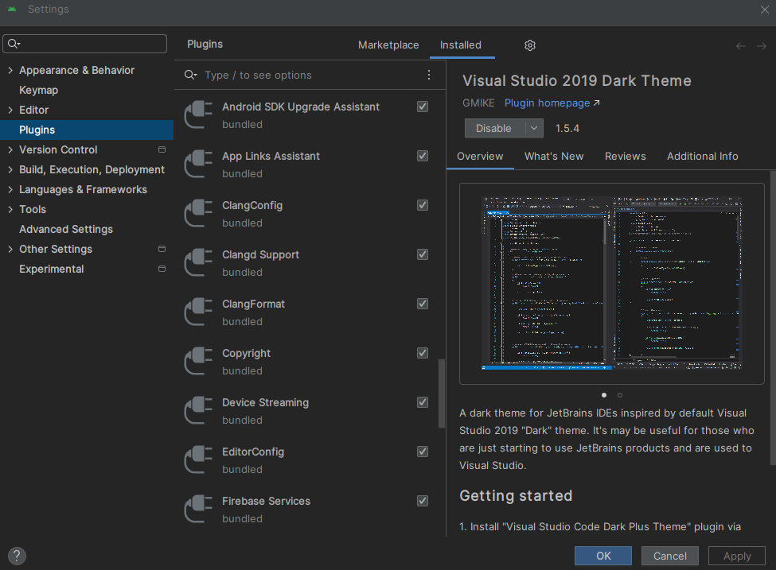

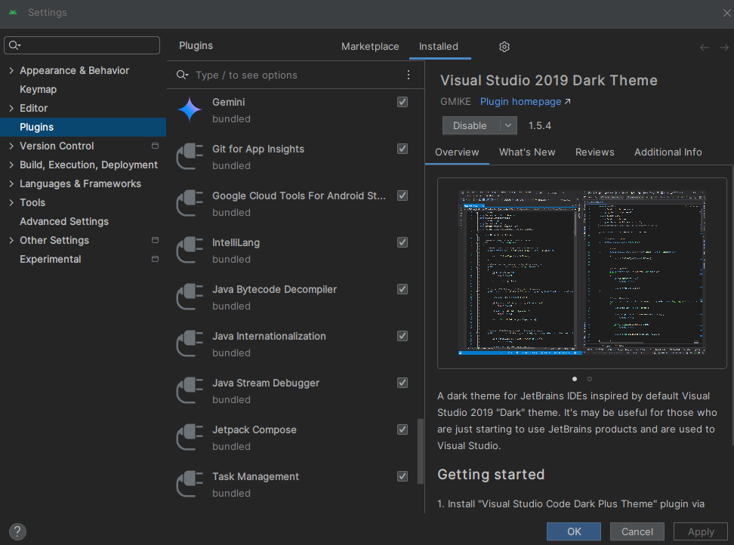

3) Captura, descripción y enlace del plugin asignado (Rainbow Brackets).

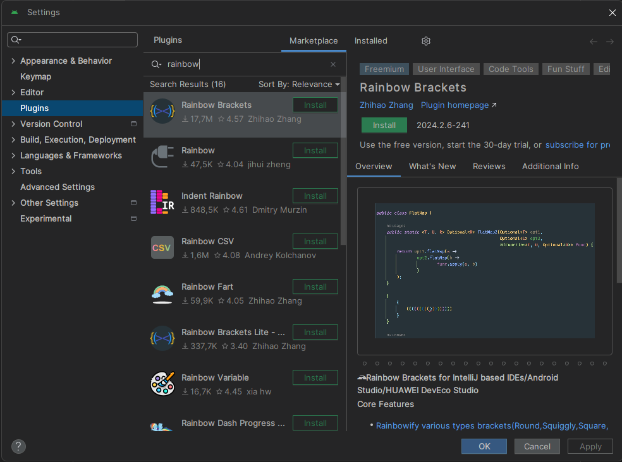Figura 1: Captura del plugin

Rainbow Brackets es un plugin que permite colorear las diferentes etiquetas o llaves para poder tener una mayor distinción entre las etiquetas padre y sus hijas.
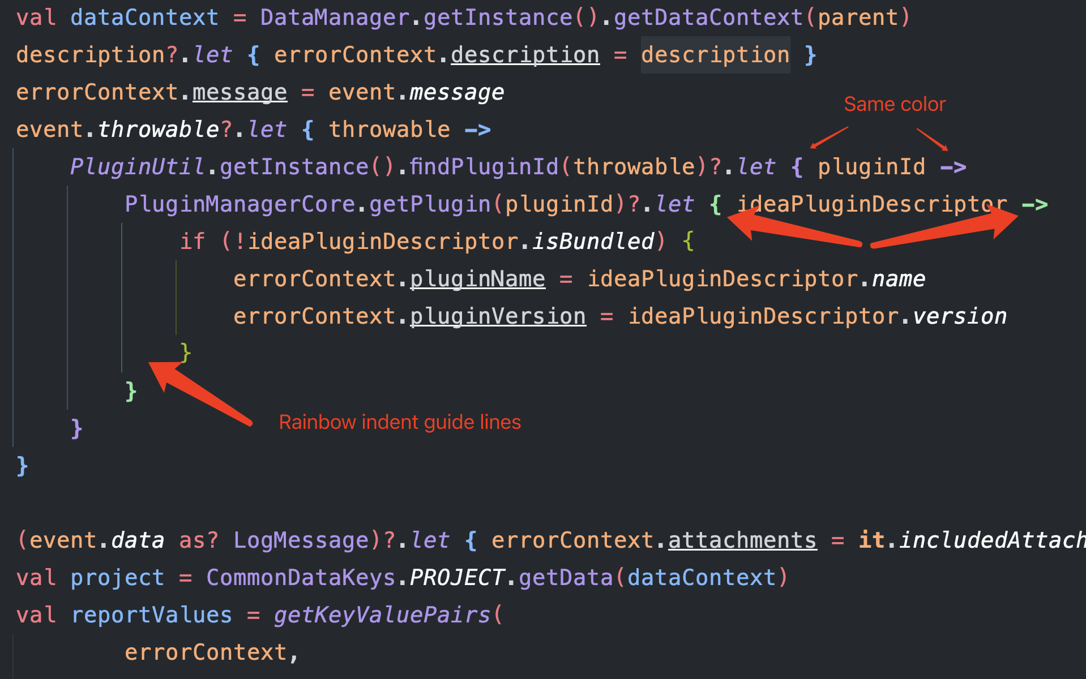Figura 2: Ejemplo 1

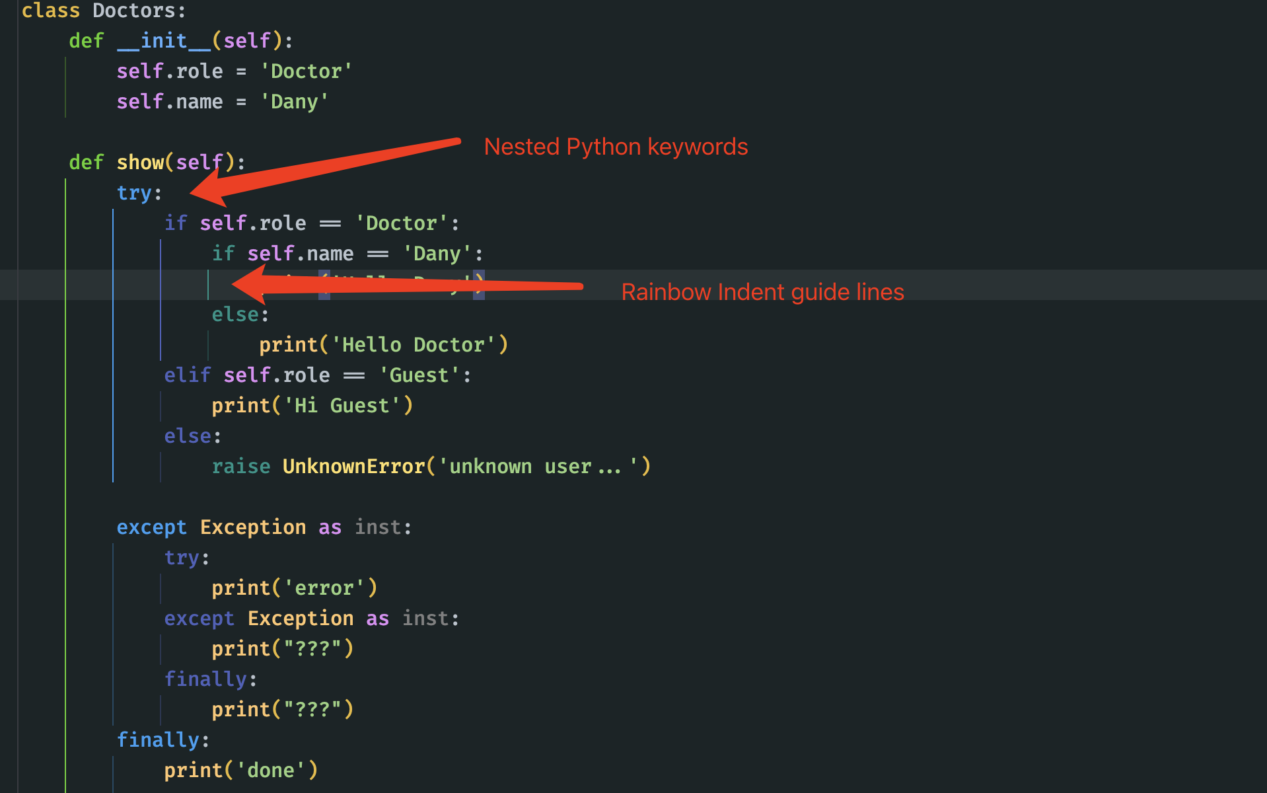Figura 3: Ejemplo 2

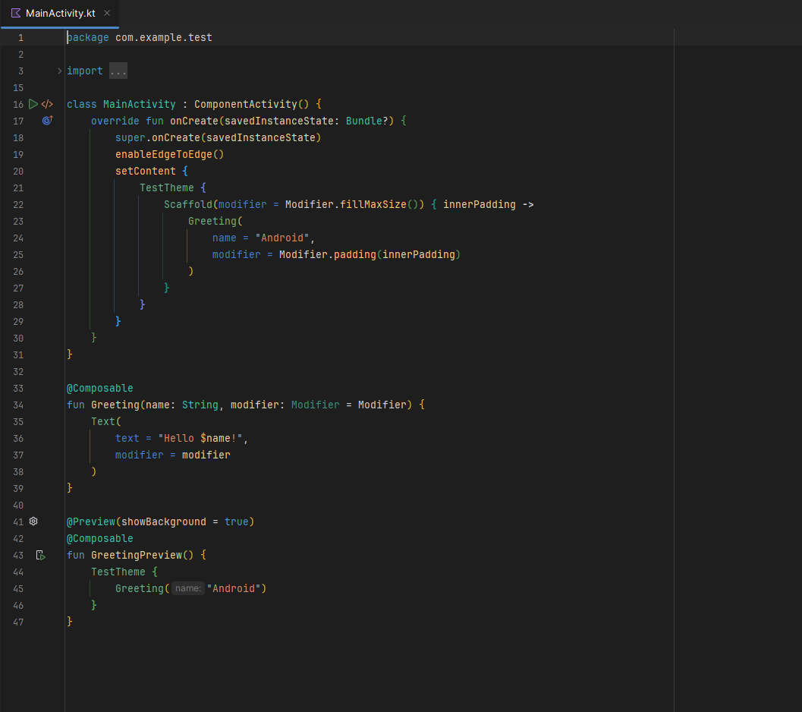Figura 4: Ejemplo 3

Enlace: https://plugins.jetbrains.com/plugin/10080-rainbow-brackets

4) Repositorios de Android

1. Repositorio developer-roadmap
Este repositorio hecho con TypeScript, nos proporciona varias guías, roadmaps y otros elementos educativos para ayudar a que los desarrolladores sigan creciendo.

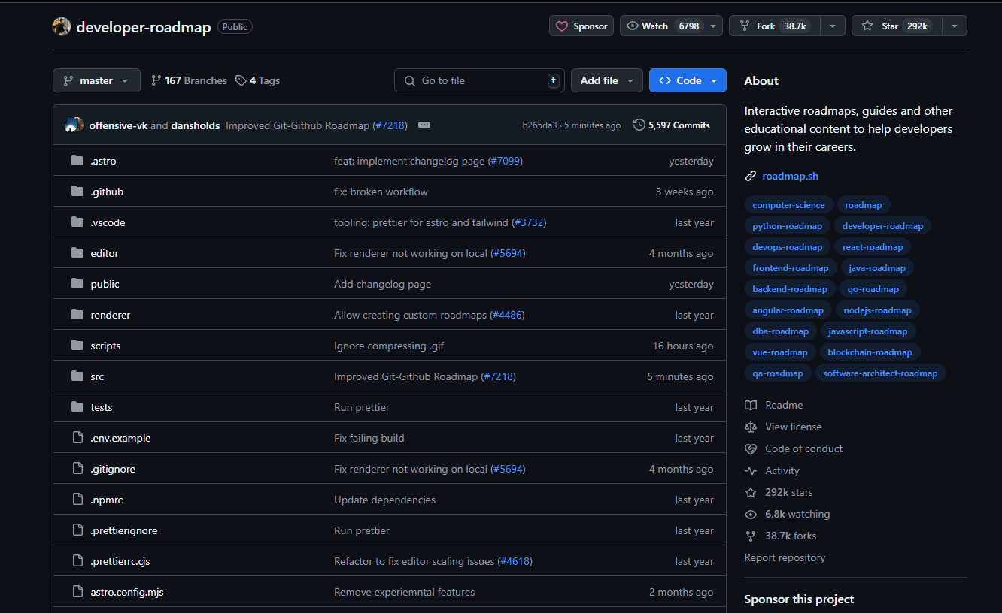Figura 5: Repositorio de developer-roadmap

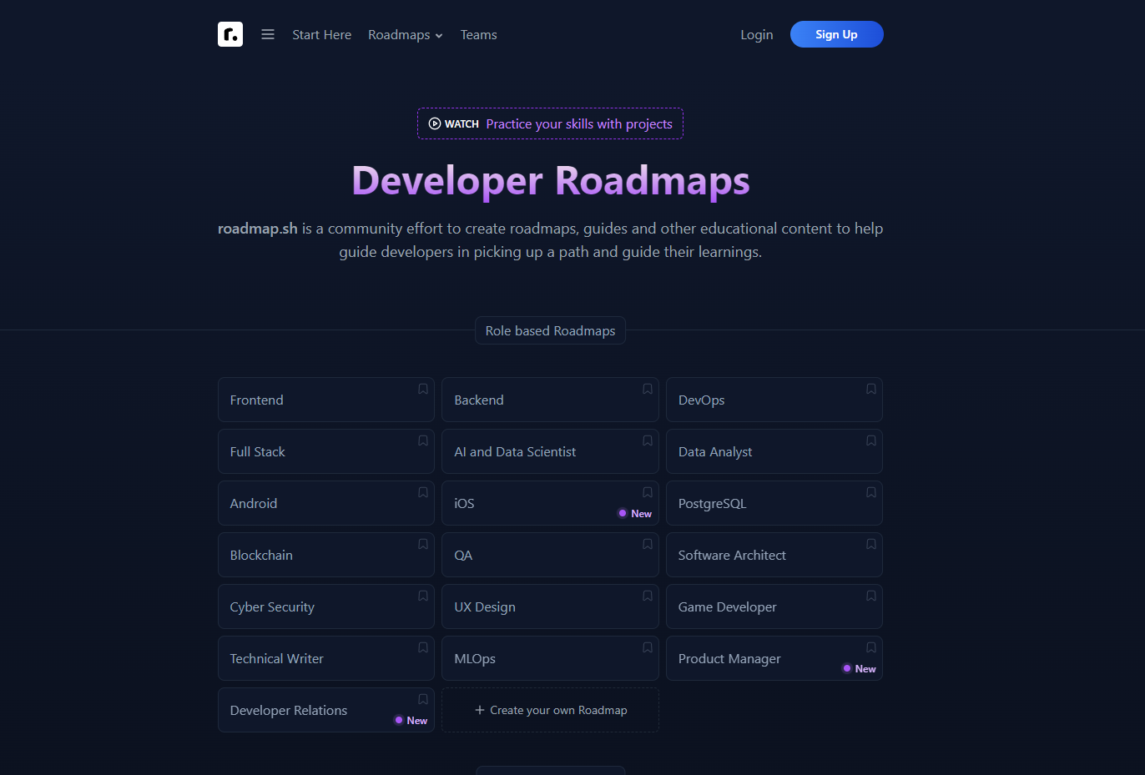Figura 6: Página web de roadmap

Enlace al repositorio: https://github.com/kamranahmedse/developer-roadmap
Enlace a la web: https://roadmap.sh/

2. Repositorio de Tolgee
Tolgee es una app creada con Kotlin, JavaScript, React entre otras, para facilitar la traducción de aplicaciones con herramientas como edición en contexto, traducción automática o memoria de traducción.

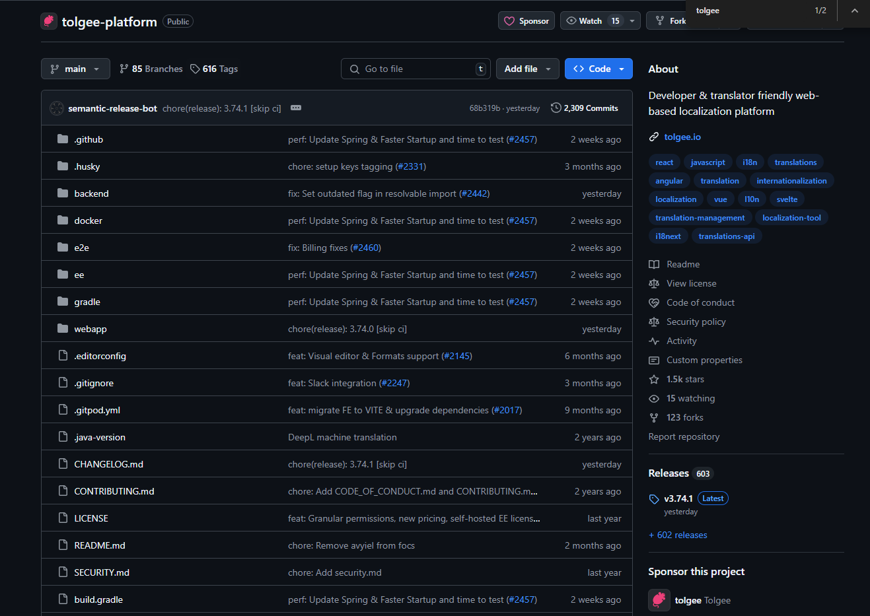Figura 7: Repositorio de Tolgee

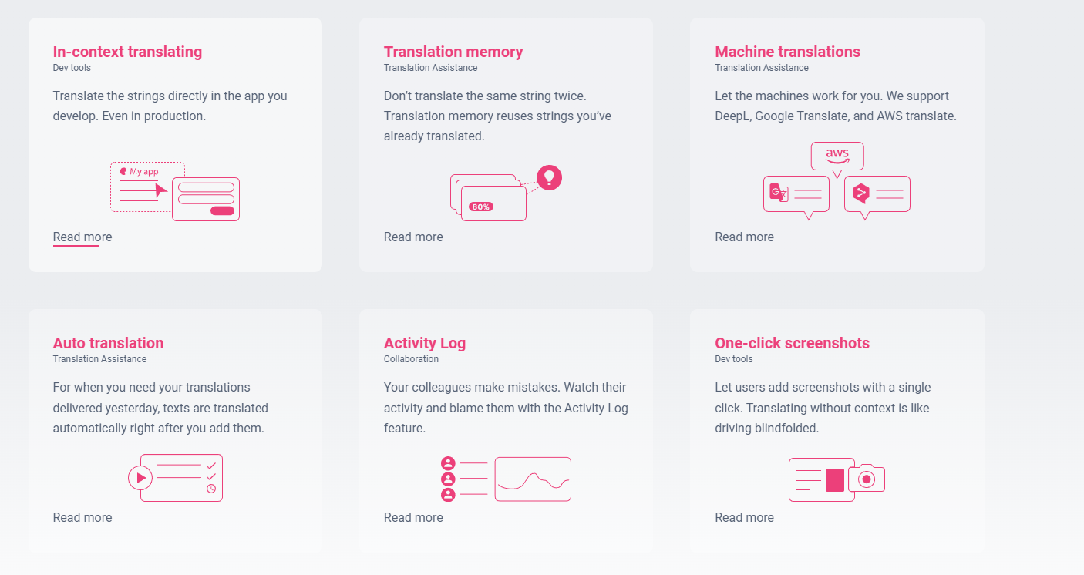Figura 8: Diferentes herramientas que Tolgee proporciona

Enlace al repositorio: https://github.com/tolgee/tolgee-platform
Enlace a la web: https://tolgee.io/

5) Cómo se importa un proyecto de GitHub en Android Studio?

1. Primero debemos ir al repositorio del proyecto que deseamos descargar y pulsar en “<> Code” y luego en “Download ZIP”.

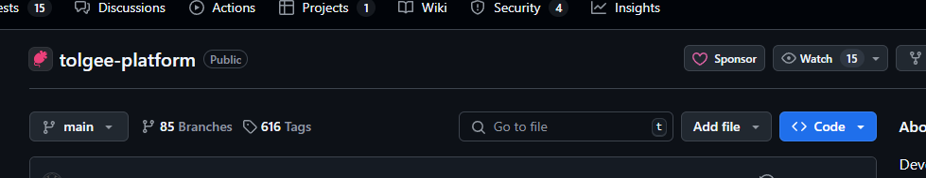Figura 9: Boton <>Code

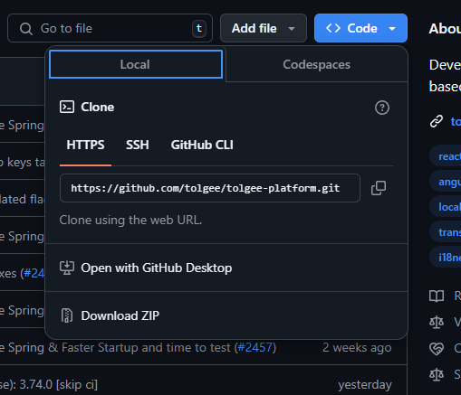Figura 10: Download ZIP

2. El paso siguiente será abrir Android Studio. Una vez dentro pulsaremos en las tres barras de la esquina superior izquierda y le daremos en “File” → “Open”.
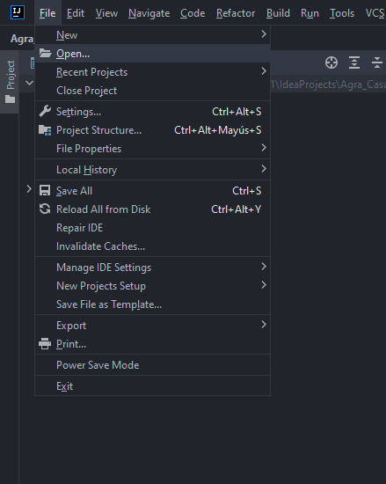Figura 11: Open Project

3. Luego deberemos indicar la ruta donde se encuentra el proyecto y pulsaremos en “Ok”.
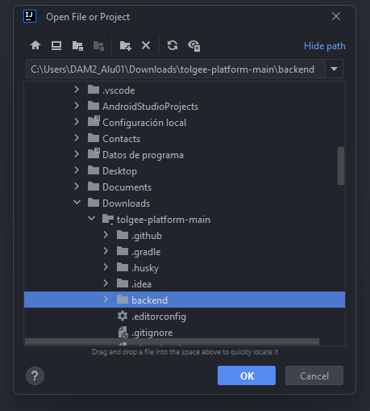Figura 12: Ruta absoluta del proyecto

4. Por último nos saldrá un aviso de seguridad. Pulsamos en “Trust Project”.

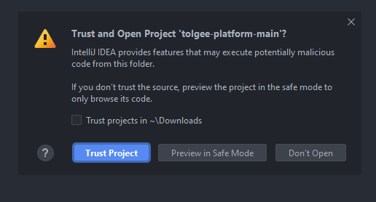Figura 13: Trust Project

Finalmente tendremos el proyecto ya importado.
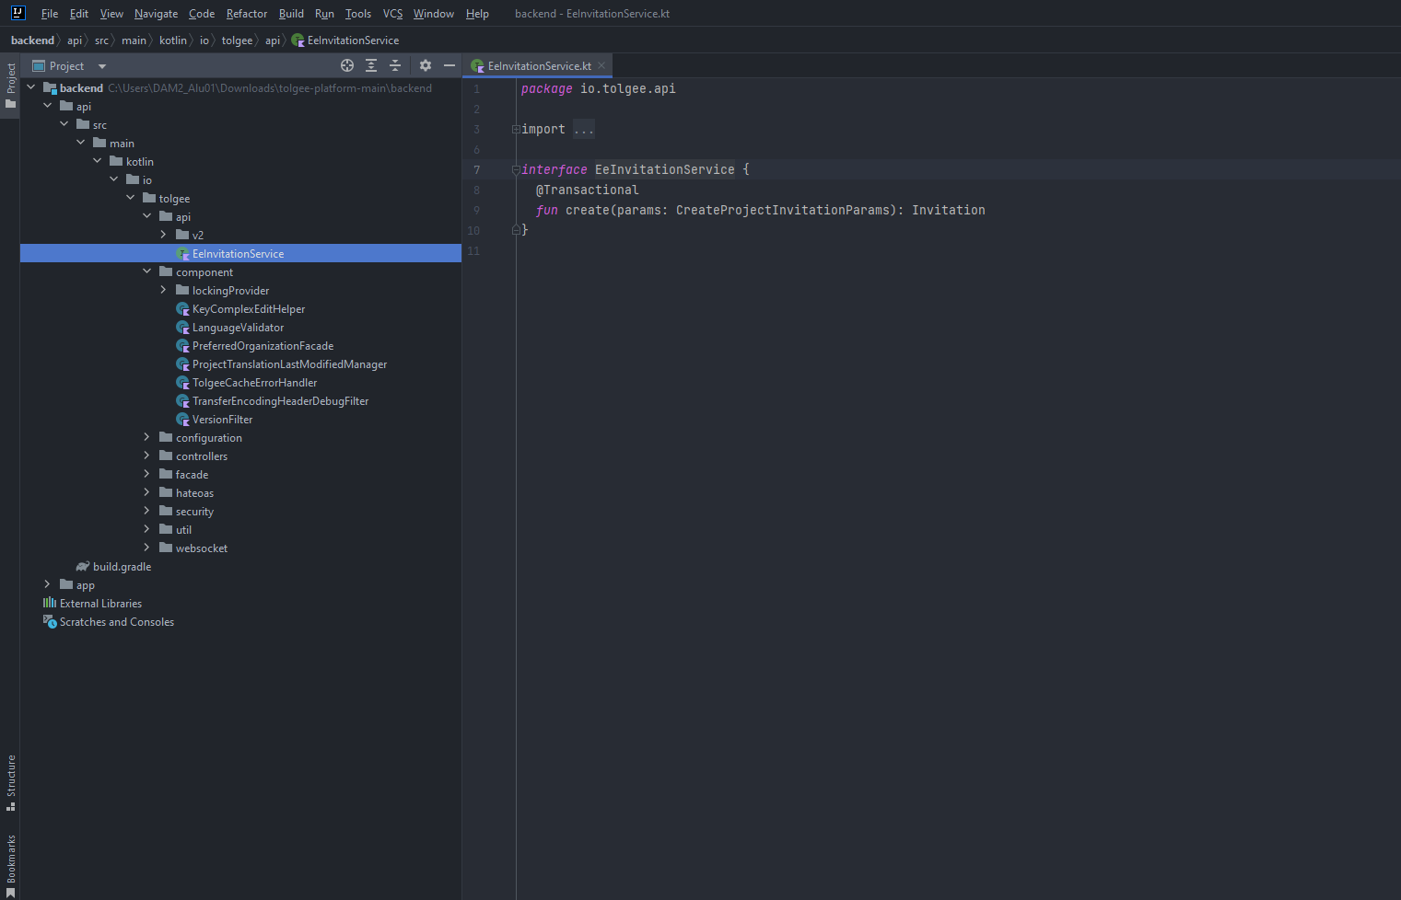Figura 14: Proyecto importado

5.2) Readme del documento

<h1 align="center" style="border-bottom: none">
<b>
<a href="https://tolgee.io">Tolgee</a><br>
</b>
An open-source localization platform<br/> developers enjoy to work with
<br>
</h1>
<div align="center">
[![Logo](https://user-images.githubusercontent.com/18496315/188628892-33fcc282-26f1-4035-8105-95952bd93de9.svg)](https://tolgee.io)
An open-source alternative to Crowdin, Phrase or Lokalise
![example workflow](https://github.com/tolgee/tolgee-platform/actions/workflows/test.yml/badge.svg)
![kotlin](https://img.shields.io/github/languages/top/tolgee/tolgee-platform)
[![docker](https://img.shields.io/docker/v/tolgee/tolgee/latest?label=DockerHub)](https://hub.docker.com/repository/docker/tolgee/tolgee)
[![github release](https://img.shields.io/github/v/release/tolgee/tolgee-platform?label=GitHub%20Release)](https://github.com/tolgee/tolgee-platform/releases/latest)
![licence](https://img.shields.io/badge/license-Apache%202%20%2F%20Tolgee%20EL-blue)
[![github stars](https://img.shields.io/github/stars/tolgee/tolgee-js?style=social&label=Tolgee%20JS)](https://github.com/tolgee/tolgee-js)
[![github stars](https://img.shields.io/github/stars/tolgee/tolgee-platform?style=social&label=Tolgee%20Platform)](https://github.com/tolgee/tolgee-platform)
[![Github discussions](https://img.shields.io/github/discussions/tolgee/tolgee-platform)](https://github.com/tolgee/tolgee-platform/discussions)
</div>
<div align="center">
[<img src="https://img.shields.io/badge/-Facebook-424549?style=social&logo=facebook" height=25 />](https://www.facebook.com/Tolgee.i18n)
[<img src="https://img.shields.io/badge/-Twitter-424549?style=social&logo=twitter" height=25 />](https://twitter.com/Tolgee_i18n)
[<img src="https://img.shields.io/badge/-Linkedin-424549?style=social&logo=linkedin" height=25 />](https://www.linkedin.com/company/tolgee)
**Become part of the family. Join [slack channel <img src="https://img.shields.io/badge/-Tolgee Comunity-424549?style=social&logo=slack" height=25 />](https://join.slack.com/t/tolgeecommunity/shared_invite/zt-195isb5u8-_RcSRgVJfvgsPpOBIok~IQ)**
</div>
![Tolgee](https://user-images.githubusercontent.com/18496315/188632536-3547fd70-755c-4a32-9b1e-fb1afbf84b33.png)
## Quick links
- [Tolgee Website](https://tolgee.io)
- Product (Learn more about the great features)
- [Dev tools](https://tolgee.io/features/dev-tools)
- [Translation assistance](https://tolgee.io/features/translation-assistance)
- [Collaboration](https://tolgee.io/features/collaboration)
- Integrations (Learn how to integrate Tolgee with you favourite technology)
- [React](https://tolgee.io/integrations/react)
- [Angular](https://tolgee.io/integrations/angular)
- [Vue](https://tolgee.io/integrations/vue)
- [Svelte](https://tolgee.io/integrations/svelte)
- [Next.js](https://tolgee.io/integrations/next)
- [More...](https://tolgee.io/integrations/all)
- [Tolgee platform docs](https://tolgee.io/docs/platform)
- [Self-hosting](https://tolgee.io/docs/platform/self_hosting/running_with_docker)
- [Development notes (How to develop Tolgee locally)](https://github.com/tolgee/tolgee-platform/wiki/Development)
## Why to use Tolgee?
Beacause it saves a lot of time you would spend on localization tasks without it. Because it enables you to provide perfectly translated software.
![Frame 47](https://user-images.githubusercontent.com/18496315/188637819-ac4eb02d-7859-4ca8-9807-27818a52782d.png)
### In context translating & One click screenshots
Add translations in the code, and translate them directly in the app with the Tolgee i18n tool. Clicking an element while holding the ALT/option key opens a dialog where you can simply modify your strings. No need to edit large .json/.po/.whatever file. In-context translating works great also in the production environment.
Once. That's how many times you have to click to take a screenshot from your application with highlighted phrases to translate. Just ALT + click a string and hit the camera button. Boom! Screenshot generated.
![Sep-06-2022 16-38-49](https://user-images.githubusercontent.com/18496315/188672133-064d2a26-e414-4f5e-ab43-549af8cb2145.gif)
### Translating on production
In-context translating also works in the production environment of your deployed app. Using the Tolgee Tools Chrome plugin, you can simply provide your API key and start translating. This enables anybody without developer knowledge to translate your app.
### True integrations
Tolgee is not just another localization platform offering integrations that just sync your local data with the backend. Tolgee is truly integrated into your app via SDKs.
### Machine translation
We support DeepL, Google Translate, and AWS Translate. Select which services you want to use in the settings section. The machine translation features make the whole localization process significantly faster. Translators can just use translation suggestions provided by third-party machine translation services.
### Translation memory
Tolgee automatically makes suggestions from translations you already used in the project so you can translate similar phrases in a similar way.
Translation memory suggestions also show the similarity percentage, the key, and the original text of the translated string.
### Auto translation
When enabled, Tolgee automatically translates new keys using translation memory or machine translation services. Your strings are translated immediately, right after creation. Select if you would like to use translation memory and/or which machine translation service you would like to use to automatically translate new keys.
### Activity log
See who modified, reviewed or commented on the phrases in your project. Clearly.
### Comment on translations
Something look off? Tell others what you would change. You can comment every translation on Tolgee platform.
### Translation history
See the changes to specific translations of a specific key in a specific language. Something is wrong? You know where to point the finger!
For more detailed documentation about Tolgee, visit [tolgee.io](https://tolgee.io).
## Quickstart 🚀
1. Sign up at [app.tolgee.io](https://app.tolgee.io/sign_up) or access your self-hosted instance
2. Create a project
3. Follow a guide in integration section of your project
4. Have fun!
![Integration guides](https://user-images.githubusercontent.com/18496315/188818166-d70d4676-7bd2-4328-91eb-720add935ab6.gif)
## Contributors
<a href="https://github.com/tolgee/tolgee-platform/graphs/contributors">
<img alt="contributors" src="https://contrib.rocks/image?repo=tolgee/tolgee-platform"/>
</a>
Let us know what you think! #feedbackwanted ❤️

En este readme podemos ver con más detalle como funcionan sus herramientas y como empezar a utilizarla.

